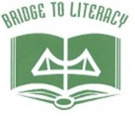
Greater Thousand Islands Literacy Council presents:
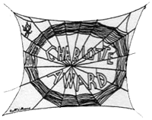
Charlotte’s Spider Bites
Charlotte Award Committee members Sarah Parker Ada and Judy Ehrensbeck will present some of their favorite titles up for the Charlotte Award
Wednesday, October 20, 2021 4:00 PM
Carthage Public Library Carthage, NY
We will be also offering this workshop via zoom for anyone that would like to do that. You must register to get the link.
CTLE credit given to those who attend.
RSVP to Judy Ehrensbeck: judy@ehrensbeck.com by 10/15/2021

